"Lighting Design in Office Spaces: Illuminating the Path to Productivity and Well-being"

ABSTRACT
Lighting design in office spaces refers to the intentional planning and implementation of lighting solutions within a workplace environment to meet the functional, aesthetic, and psychological needs of occupants.
This research paper delves into the intricate connection between lighting design, mood regulation, and productivity levels within office spaces. Through a comprehensive analysis of existing literature, it investigates how various aspects of lighting, including colour temperature, intensity, distribution, and dynamics, influence the psychological well-being and performance of employees. Additionally, the study explores the differential impacts of natural light versus artificial lighting systems on circadian rhythms, sleep quality, and overall workplace satisfaction. By considering individual preferences, task requirements, and environmental contexts, this research aims to provide insights into the optimization of lighting design for diverse office settings. Empirical research methods, such as surveys, observations, and experimental studies, are utilized to elucidate the nuanced effects of lighting on human behaviour and cognitive functions. Ultimately, this study aims to offer practical recommendations for architects, designers, and employers to create lighting environments that foster positive mood states and enhance productivity in office spaces, contributing to healthier, more engaging, and more effective work environments.
Keywords - Circadian rhythms, Natural light, Artificial light, Colour temperature, Illumination levels, Glare reduction, Visual comfort, Task lighting, Ambient lighting

INTRODUCTION
In the modern workplace, the design of office spaces extends beyond mere functionality to encompass the holistic well-being and productivity of employees. Among the myriad factors influencing workplace dynamics, lighting design stands out as a critical determinant of mood and productivity. The interplay between lighting and human psychology has garnered increasing attention in recent years, with research highlighting its profound effects on employee satisfaction, cognitive performance, and overall workplace atmosphere.
This medium-length introduction delves into the multifaceted relationship between lighting design and its impact on mood and productivity within office environments. Through a nuanced exploration of existing literature and empirical studies, we aim to elucidate the mechanisms through which lighting influences human behaviour and organizational outcomes.
By understanding the interplay between lighting parameters such as colour temperature, intensity, and distribution, as well as the integration of natural versus artificial light sources, stakeholders can optimize office lighting to create environments that foster positive mood states and enhance productivity.

LITERATURE REVIEW
Existing theories and frameworks related to the impact of lighting on mood and productivity: -
- The Yerkes-Dodson Law: This psychological principle suggests that there is an optimal level of arousal for performance on a task. In terms of lighting, this means that there is an ideal level of illumination that maximizes productivity.
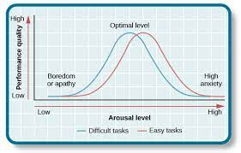

Fig1: The Yerkes-Dodson Law

- The Human Factors/Ergonomics Approach: and task-specific lighting requirements to enhance productivity and mood in workspaces.

- The Biopsychosocial Model: Regarding lighting, it considers how biological factors such as circadian rhythms, psychological factors such as mood, and social factors such as workplace culture interact to affect productivity and well-being.

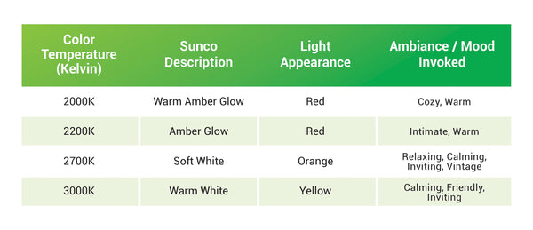
- The Colour Temperature Theory: This theory suggests that the colour temperature of light can influence mood and productivity. Cool white light is often associated with increased alertness and focus, while warm white light is linked to relaxation and comfort.
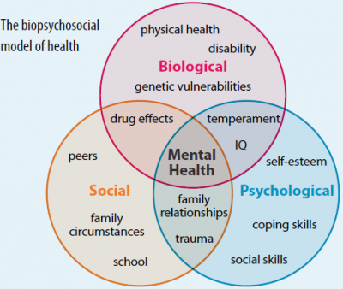

Fig 2: Biopsychosocial model Fig 3: The colour temperature theory

- The Ecological Approach: It considers factors such as natural light exposure, views of nature, and the overall ambiance of the workspace in shaping mood and productivity.

- The Attention Restoration Theory (ART): Proposed by Rachel and Stephen Kaplan. This theory highlights the importance of incorporating natural elements into workspaces to mitigate the effects of mental fatigue and promote well-being
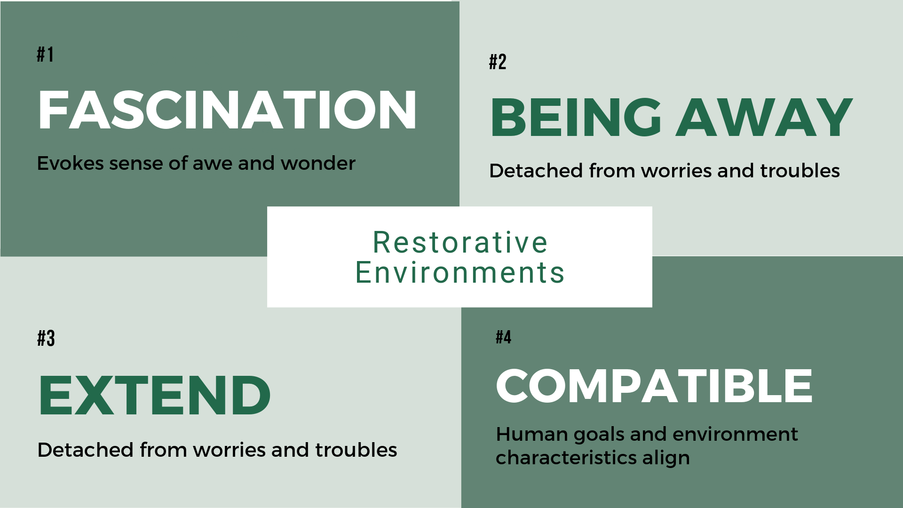
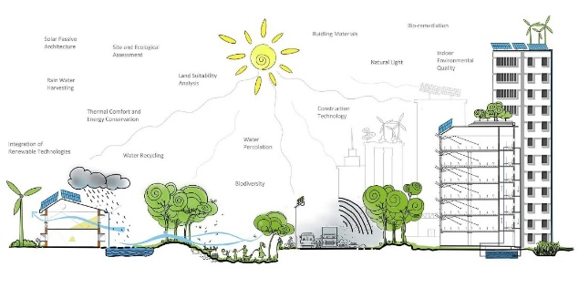
Fig 4: The Ecological approach Fig 5: The Attention restoration theory

- The Regulatory Fit Theory: This theory suggests that individuals seek environments that match their regulatory preferences.
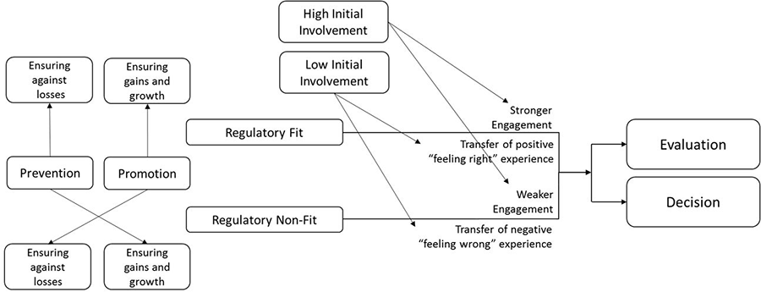

Fig 6: The Regulatory Fit theory

psychological theories that explain the connection between lighting and human behaviour: -
- Circadian Rhythm Theory: This theory focuses on the role of lighting in regulating the body's internal clock, known as the circadian rhythm.
Light exposure, particularly natural light, helps synchronize the circadian rhythm, influencing physiological processes such as sleep-wake cycles, hormone secretion, and body temperature regulation.

- Arousal Theory: Arousal theory posits that variations in environmental stimuli, including lighting, can modulate physiological arousal levels, which in turn influence mood, attention, and performance.
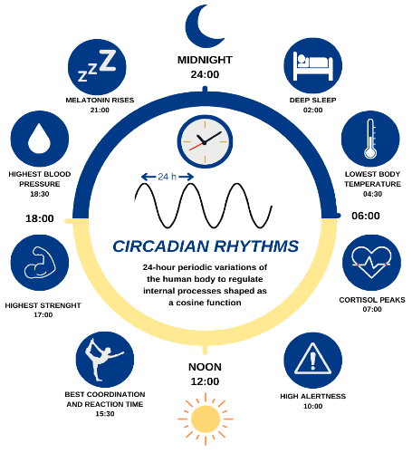
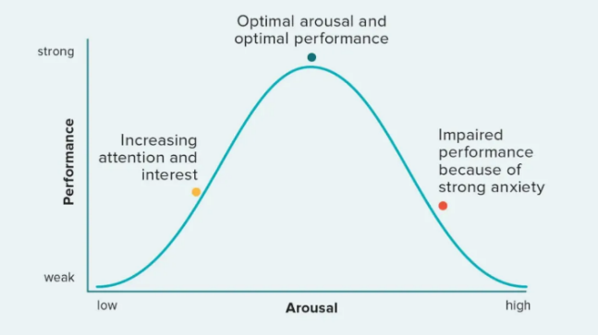

Fig 7: Circadian Rhythm Theory Fig 8: Arousal Theory
- Mood Regulation Theory: This theory suggests that lighting can influence mood through its effects on emotional processing and regulation. Bright, natural light exposure has been linked to improvements in mood, energy levels, and emotional well-being, while inadequate or harsh lighting conditions may contribute to negative affective states such as stress, anxiety, and irritability.

- Environmental Psychology Theories: ART proposes that exposure to natural environments or elements, including daylight, can restore cognitive resources depleted by mental fatigue, thereby improving attention, focus, and mood.
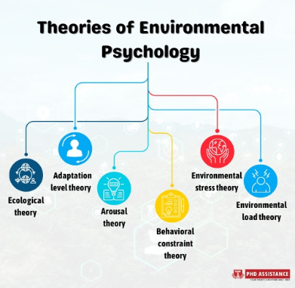

Fig 9: Environmental psychology theories

- Social Influence Theory: Social factors, such as social norms, group dynamics, and interpersonal interactions, can also influence individuals' perceptions and responses to lighting environments.

Some specific gaps in the literature related to the comparison between natural and artificial lighting that my research aims to address: -
- Integration of Natural and Artificial Lighting: Many studies focus on either natural or artificial lighting separately, but there's a lack of research that comprehensively examines how the integration of both types of lighting can optimize the work environment.

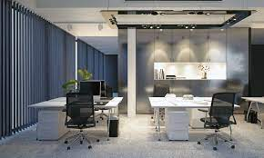
- Spatial Considerations: My research aims to investigate how the strategic placement of natural and artificial light sources can influence different areas within an office, such as workstations, collaborative zones, and relaxation areas, to optimize functionality and comfort.

Fig 10 : Spatial Considerations

- Seasonal Variations: My research intends to address this gap by examining how seasonal changes affect lighting conditions in offices and exploring strategies to mitigate any negative effects, such as daylight harvesting systems or adaptive lighting controls.

- Long-term Effects: While some research has examined short-term effects, such as immediate changes in productivity or mood, there's a lack of longitudinal studies that assess the long-term impacts of natural and artificial lighting on employee well-being and performance. My research aims to fill this gap by investigating how sustained exposure to optimized lighting conditions influences employee satisfaction, retention, and overall organizational outcomes over time.

Effects of natural and artificial lighting on mood and productivity:-
Natural Lighting:
Mood: Exposure to natural light has been consistently linked to positive effects on mood. Sunlight triggers the release of serotonin in the brain, which contributes to feelings of well-being and happiness. People exposed to natural light tend to report lower levels of stress, anxiety, and depression.
Productivity: It helps regulate circadian rhythms, which can improve alertness and cognitive function. Employees exposed to natural light often demonstrate higher levels of concentration, motivation, and job satisfaction
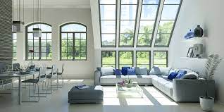
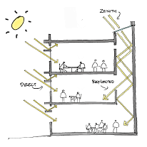
Fig 11: - Natural lighting or daylight
Artificial Lighting:
Mood: The effects of artificial lighting on mood can vary depending on factors such as color temperature, intensity, and duration of exposure. Cool white light with higher color temperatures (e.g., 5000-6500 Kelvin) tends to promote alertness and positive mood, while warmer light with lower color temperatures (e.g., 2700-3000 Kelvin) creates a more relaxed atmosphere.
Productivity: Artificial lighting can impact productivity both positively and negatively. Properly designed artificial lighting systems with appropriate intensity and color temperature can enhance visibility, reduce eye strain, and promote task performance
Fig 12 : - Artificial lighting
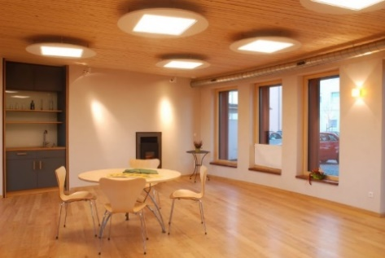
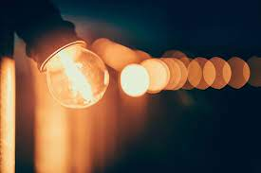

Balancing natural lighting and artificial lighting in office spaces is crucial for several reasons:
- Employee Well-being: Natural light has been linked to improved mood, reduced stress, and better overall well-being. By incorporating ample natural light into office spaces, employees are more likely to feel happier, healthier, and more satisfied with their work environment.
- Productivity: Natural light promotes alertness and enhances cognitive function, which can lead to increased productivity among employees. Balancing natural and artificial lighting ensures optimal lighting conditions throughout the day, helping employees maintain focus and perform tasks more efficiently.
- Energy Efficiency: Leveraging natural light reduces reliance on artificial lighting sources, leading to lower energy consumption and operational costs for organizations. By strategically positioning workspaces and utilizing daylight harvesting systems, businesses can maximize natural light intake and minimize the need for artificial lighting during daylight hours.

Fig13: Natural light increases focus and Fig14: Maintains Employee well being Increase productivity.
- Visual Comfort: Balancing natural and artificial lighting helps create a visually comfortable workspace for employees. Natural light provides softer, more diffused illumination, reducing glare and minimizing eyestrain..

- Biophilic Design: Integrating natural elements, such as natural light, into office spaces aligns with biophilic design principles, which emphasize connections with nature to promote well-being and productivity. Balancing natural and artificial lighting enhances the biophilic qualities of the workspace, creating a more harmonious and inviting environment for employees.

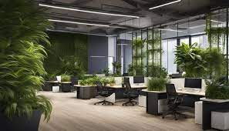
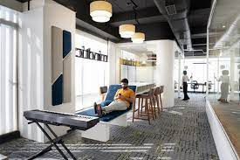

Fig 15: Integrating biophilic design in office Fig 16: Visual comfort provide flexibility

METHODOLOGY
Research Approach: -
Data Collection Methods:
Surveys: Quantitative surveys will be conducted to gather data on employees' perceptions of lighting conditions, mood, and productivity in their office environment.
Observations: Qualitative observations will be conducted to document the physical characteristics of the office space, including the distribution of natural and artificial lighting, layout design, and environmental factors. Observations will also focus on employee behavior and interactions within the workspace.
Experiments: Experimental studies will be conducted to assess the direct impact of lighting conditions on mood and productivity. Participants will be exposed to different lighting conditions (natural light, artificial light with varying colour temperatures and intensities) while performing cognitive tasks or simulations of typical office work.
Sample Selection:
Office Spaces:
- Size: Office spaces selected will vary in size, ranging from small to large, to capture a diverse range of environments.
- Layout: Offices with different layouts, including open-plan, cubicles, and private offices, will be included to account for variations in lighting distribution and employee interactions.
- Lighting Conditions: Offices will have a mix of natural and artificial lighting sources, with variations in daylight exposure, window placement, and lighting fixtures.
- Industry: Offices from various industries, such as technology, finance, healthcare, and education, will be considered to ensure diversity in workplace settings.
Participants:
- Occupation: Participants will include employees from different occupational backgrounds, such as administrative staff, managers, engineers, and designers, reflecting the diverse roles found in office environments.
- Demographics: Participants will represent a range of demographic characteristics, including age, gender, education level, and years of experience, to capture diverse perspectives and experiences.
- Work Experience: Both seasoned professionals and newcomers to the workforce will be included to account for differences in familiarity with office environments and lighting conditions.
- Office Location: Participants will be selected from offices located in urban, suburban, and rural settings to account for potential differences in natural light exposure and environmental factors.

LIGHTING DESIGN ELEMENTS

- Light Source: The type of light source used, such as incandescent, fluorescent, LED, or natural light, determines factors like colour rendering, energy efficiency, and maintenance requirements.
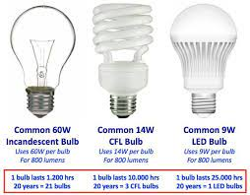

Fig17: Light sources

- Colour Temperature: Colour temperature, measured in Kelvin (K), refers to the warmth or coolness of light emitted by a source. Warm temperatures (lower Kelvin) create a cozy atmosphere, while cooler temperatures (higher Kelvin) promote alertness and productivity.
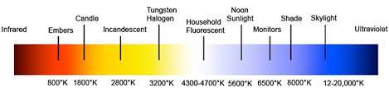

Fig18: Colour temperature in lighting

- Intensity: Intensity refers to the brightness or luminous flux emitted by a light source, measured in lumens (lm). Proper intensity levels ensure adequate visibility for tasks and activities while maintaining visual comfort.
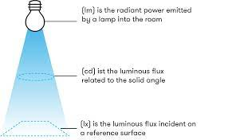

Fig19: Intensity

- Distribution and Placement: Proper distribution and placement of lighting fixtures ensure uniform illumination and minimize glare and shadows. Considerations include fixture location, spacing, angle, and mounting height.
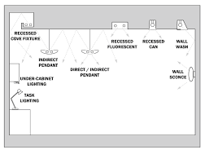

Fig20: Proper distribution and placement of lighting fixture ensures uniform illumination

- Lighting Controls: Lighting control systems allow for precise adjustment of lighting parameters such as intensity, colour temperature, and timing. Automated controls, occupancy sensors, and daylight harvesting systems enhance energy efficiency and user comfort.

- Lighting Layers: Effective lighting design incorporates multiple layers of light, including ambient (general), task, accent, and decorative lighting, to fulfil various functional and aesthetic requirements.
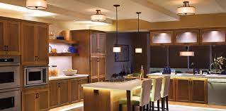

Fig 21: Layers of lighting(Task , accent ,ambient lighting)
- Daylighting Strategies: Daylighting strategies harness natural light to supplement artificial lighting, reducing energy consumption and providing visual and physiological benefits to occupants. Design considerations include window placement, size, orientation, and shading devices.
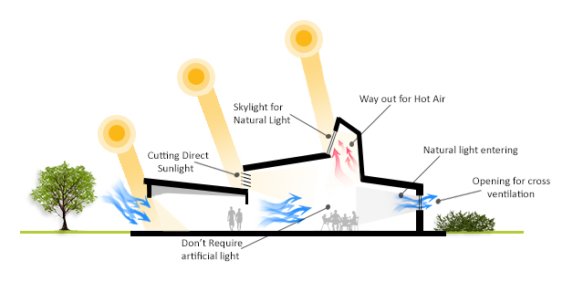

Fig 22: Daylight Strategies

- Aesthetics and Visual Comfort: Lighting design considers the aesthetic appeal and visual comfort of the space, incorporating fixtures, finishes, and lighting effects that complement the architectural style and create visually pleasing compositions while minimizing glare and discomfort.
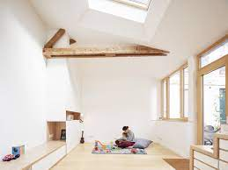

Fig 23: Aesthetic and visual comfort
Impact of different colour temperatures and intensity levels on mood.
Colour Temperature:
- Warm Light (2700-3000 K): Warm light with lower colour temperatures tends to evoke feelings of coziness, comfort, and relaxation. It can create a welcoming ambiance to sunset or candlelight, promoting a sense of intimacy and warmth. Warm lighting is often preferred in residential spaces, dining areas, and hospitality environments to encourage relaxation and social interaction.
- Cool Light (5000-6500 K): Cool light with higher colour temperatures has a more stimulating effect, promoting alertness, focus, and productivity. It resembles natural daylight or overcast sky and can enhance feelings of energy and vitality. Cool lighting is commonly used in workspaces, classrooms, and retail settings to create an invigorating environment conducive to concentration and task performance.
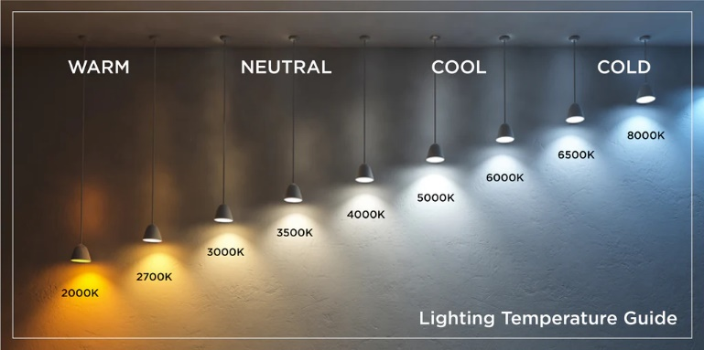

Fig24:- Colour temperature in light

Intensity Levels:
- High Intensity: Higher intensity lighting tends to elicit feelings of brightness, energy, and activity. Bright light can increase alertness and elevate mood by stimulating the brain's production of serotonin, a neurotransmitter associated with feelings of well-being and happiness.
- Low Intensity: Lower intensity lighting, on the other hand, creates a softer, more subdued ambiance conducive to relaxation and comfort. Dim lighting can promote feelings of calmness, tranquillity, and intimacy, making it suitable for mood-enhancing activities such as meditation, reading, or unwinding before bedtime
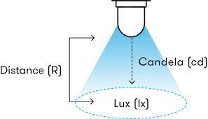

Fig25: Intensity of lighting

Personalized lighting design
Personalized lighting design involves tailoring lighting solutions to meet the specific needs, preferences, and characteristics of individual users or occupants.
User-Centric Approach: Personalized lighting design starts with understanding the unique requirements and preferences of individual users. This may involve conducting surveys, interviews, or assessments to gather information about users' lighting preferences, visual comfort preferences, task requirements, and circadian rhythms.
Customizable Lighting Controls: Personalized lighting design incorporates customizable lighting controls that allow users to adjust lighting parameters such as intensity, color temperature, and lighting scenes according to their preferences and activities.
Tunable White Lighting: Tunable white lighting systems allow users to adjust the color temperature of light dynamically, mimicking the natural changes in daylight throughout the day. This feature enables users to create lighting environments that align with their circadian rhythms and promote alertness during the day and relaxation in the evening.
Task-Specific Lighting Solutions: Task-specific lighting solutions, such as adjustable task lights or localized lighting fixtures, provide focused illumination for activities such as reading, computer work, or artwork. By optimizing lighting levels and glare control for each task, personalized lighting design enhances visual comfort and task performance for occupants.

MOOD AND PRODUCTIVITY ANALYSIS

Tools or methods for assessing the mood of individuals in office spaces: -
- Surveys and Questionnaires: Surveys and questionnaires are commonly used to assess individuals' mood and subjective experiences in office settings. These tools typically include Likert scale questions or open-ended prompts to gauge various dimensions of mood, such as happiness, stress, energy level, and overall satisfaction with the work environment.

- Interviews: In-depth interviews provide an opportunity for individuals to express their feelings, perceptions, and experiences in greater detail. Structured or semi-structured interviews can be conducted one-on-one or in focus group settings to explore participants' mood states, identify factors influencing mood, and gather insights into their preferences for office design and lighting conditions.

- Observations: Observational methods involve systematically recording individuals' behaviours, interactions, and non-verbal cues in office environments.

Trained observers or researchers may use behavioural coding schemes or checklists to document observable indicators of mood, such as facial expressions, body language, vocal tone, and social interactions. Observations can provide valuable insights into the contextual factors influencing mood and help identify areas for improvement in the office environment.

Impact of lighting design on employee performance and productivity: -
- Visibility and Task Performance: Insufficient lighting can lead to visual discomfort, eyestrain, and errors in task performance, while appropriate lighting levels and glare control enhance visual clarity and accuracy.

- Alertness and Concentration: Bright, cool lighting during the daytime hours promotes wakefulness, attention, and mental alertness, facilitating tasks that require sustained concentration and problem-solving.

- Mood and Motivation: Lighting design can impact employees' mood, motivation, and job satisfaction by creating a comfortable and stimulating work environment. Natural light has been shown to positively affect mood and reduce symptoms of depression and anxiety among employees.

- Biological Rhythms and Health: Lighting design influences employees' biological rhythms and physiological well-being by regulating the secretion of hormones such as melatonin and cortisol. Exposure to appropriate lighting conditions throughout the day helps synchronize circadian rhythms, promoting restful sleep at night and optimal alertness during the day.
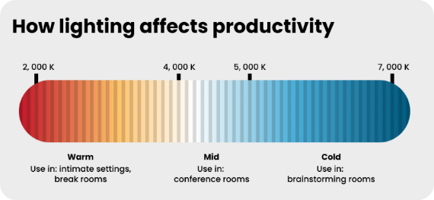

Fig26: - lighting affects productivity

CASE STUDIES

Case Study 1: Google's Headquarters (Googleplex) - Mountain View, California
Google's headquarters, known as the Googleplex, is renowned for its innovative and employee-friendly design, including its lighting solutions. The office features a combination of natural daylighting, high-quality artificial lighting fixtures, and advanced lighting controls to create a comfortable and productive work environment.
Lighting Design Features:
- Abundant Natural Light: Extensive use of floor-to-ceiling windows, skylights, and atriums allows ample natural light to penetrate deep into the office spaces, reducing the need for artificial lighting during daylight hours.
- Dynamic Lighting Controls: Advanced lighting control systems adjust artificial lighting levels and colour temperatures throughout the day to complement natural light, promote circadian rhythms, and enhance visual comfort.
- Varied Lighting Scenes: Flexible lighting controls enable employees to customize lighting scenes based on their preferences and activities, supporting a diverse range of workstyles and tasks.
Impact on Mood and Productivity:
- Positive Mood: Ample natural light and dynamic lighting controls create a vibrant and uplifting atmosphere, contributing to improved mood, energy levels, and overall well-being among employees.
- Enhanced Productivity: Optimized lighting conditions support employee focus, concentration, and task performance, leading to increased productivity and creativity in the workplace.
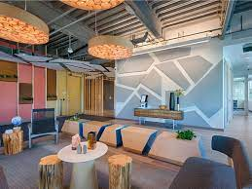

Fig 27: Google office, California

CONCLUSION

In conclusion, the findings of this research underscore the critical role of lighting design in shaping the quality of workplace environments and influencing employee well-being and performance. By adopting a holistic and evidence-based approach to lighting design, businesses and office designers can create environments that support the diverse needs and preferences of occupants, enhance productivity and creativity, and foster a sense of connection and vitality in the workplace. As organizations increasingly recognize the importance of employee health and satisfaction in driving organizational success, investing in thoughtful and innovative lighting solutions will remain essential for creating thriving and resilient workplaces in the future.
REFERENCES

1. https://wbwood.com/2022/08/29/how-lighting-affects-office-productivity/
2. https://medium.com/@arventlightsys/the-impact-of-lighting-solutions-on- mood-and-productivity-485e3faa040d
3. https://www.jaquar.com/en/does-office-lighting-impact-your-mood
4. https://onlinemba.unc.edu/news/how-lighting-affects-productivity/
5. https://flowinterio.com/blog-the-impact-of-lighting-design-on-health-and-wellbeing/

