USE OF EARTHEN MATERIALS IN INTERIOR SPACES
By Ritika Omar, B.I.D 6th semester, Amity School Of Architecture Ans Planning, Amity University Uttar Pradesh, Lucknow Campus
Mobile No. -7897699763, Email ID – ritika.omar@s.amity.edu

ABSTRACT

This dissertation investigates the utilization of earthen materials within interior spaces, focusing on their sustainable attributes and aesthetic potential. In the context of contemporary design practices, there is a growing interest in integrating natural materials that offer environmental benefits and promote well-being. Earthen materials, including clay, adobe, terracotta, and rammed earth, present promising opportunities for sustainable interior design solutions. The research begins by examining the historical and cultural significance of earthen architecture and its evolution through time. Drawing upon case studies from various regions around the world, the dissertation highlights the versatility and adaptability of earthen materials in diverse climates and contexts. The study explores the physical properties and environmental characteristics of earthen materials, such as their thermal mass, breathability, and low embodied energy. These attributes contribute to improved indoor air quality, energy efficiency, and overall comfort within interior spaces. Through a review of contemporary design projects and innovative applications, the dissertation showcases the creative potential of earthen materials in interior design. From textured wall finishes to handcrafted furniture and lighting fixtures, earthen elements add warmth, texture, and visual interest to interior environments. The dissertation discusses the implications of using earthen materials from a sustainable design perspective, considering factors such as material sourcing, life cycle analysis, and cultural preservation. By embracing earthen materials in interior design, designers and architects can contribute to the promotion of sustainable lifestyles and the conservation of natural resources.

INTRODUCTION
The dissertation clearly inclines towards the revival of our traditional materials like mud, clay, stones, rammed earth etc which were used to build forts , palaces and houses. These materials are sustainable and easily available in every state and city of India, moreover these materials are available at a very reasonable price which results in cost reduction of bigger projects. The dissertation stresses over the application of earthen materials in interior spaces rather than synthetic materials due to their environmental and economical benefits.
The use of earthen materials in interior spaces is a timeless practice that has endured through centuries of architectural evolution. From ancient civilizations to modern eco-conscious designs, the integration of earthen elements brings a sense of connection to nature and a unique aesthetic appeal to indoor environments. Earthen materials encompass a wide range of substances sourced directly from the earth, including clay, mud, adobe, rammed earth, and natural stones. These materials offer numerous benefits beyond their aesthetic qualities. They provide excellent thermal mass, helping to regulate indoor temperatures naturally, which can contribute to energy efficiency and comfort.
In this exploration of the use of earthen materials in interior spaces, we will delve into the historical significance, contemporary applications, and sustainable advantages of incorporating these elements into architectural and interior design. From rustic charm to minimalist elegance, earthen materials offer versatility and character that can transform any interior space into a harmonious sanctuary that resonates with the natural world.

KEYWORDS
Earthen construction, sustainable building, vernacular architecture, environmental impact, cultural heritage, energy efficiency, construction techniques, thermal properties, rammed earth ,cob construction ,earthen plasters

HOW ARE THEY BENEFICIAL FOR INTERIOR SPACES-
Earthen materials offer a myriad of benefits when incorporated into interior spaces, making them a compelling choice for architects, designers, and homeowners alike. Their natural composition, including clay, mud, and adobe, brings a unique warmth and organic texture to indoor environments. Beyond aesthetics, earthen materials possess remarkable thermal properties, helping to regulate indoor temperatures and create comfortable living spaces year-round. Their ability to absorb and release moisture contributes to balanced humidity levels, promoting healthier indoor air quality and reducing the risk of mold and mildew. Moreover, earthen materials are sustainable and environmentally friendly, often sourced locally and requiring minimal energy for production. This eco-conscious approach aligns with contemporary design principles and fosters a deeper connection to the natural world within interior spaces.

SUSTAINABILITY-
Earthen materials stand as a beacon of sustainability and environmental stewardship in the realm of construction and design. Their inherent properties and production processes offer numerous benefits that harmonize with ecological principles and contribute to a healthier planet. First and foremost, earthen materials are sourced from natural elements such as clay, mud, and sand, which are abundant and renewable resources. Their extraction incurs minimal environmental impact compared to the mining and processing of industrial materials like concrete and steel. Furthermore, the production of earthen materials requires far less energy and emits fewer greenhouse gases.. Additionally, earthen buildings possess excellent thermal mass properties, meaning they can naturally regulate indoor temperatures, reducing the need for energy-intensive heating and cooling systems.

HEALTH BENEFITS
They offer a plethora of health benefits that contribute to creating safer and more comfortable living environments. Unlike synthetic materials that may off-gas harmful chemicals, earthen materials such as clay, mud, and adobe are natural and non-toxic, promoting better indoor air quality. Their porous nature allows them to absorb excess moisture and regulate humidity levels, reducing the risk of Mold and mildew growth that can trigger respiratory issues and allergies.
Additionally, earthen materials possess excellent thermal mass properties, helping to maintain stable indoor temperatures and reducing the need for artificial heating and cooling systems. This not only enhances occupant comfort but also promotes better sleep quality and overall well-being. Furthermore, the tactile and organic textures of earthen materials create a sense of connection to the natural environment, fostering mental relaxation and stress reduction. In essence, incorporating earthen materials into interior spaces promotes a healthier and more harmonious living environment for occupants, where sustainability and well-being go hand in hand.
TYPES OF EARTHEN MATERIALS
Earthen materials have a rich history of use in interior spaces dating back thousands of years. These materials, which include clay, mud, adobe, rammed earth, and plaster, have been favoured for their abundance, accessibility, thermal properties, and aesthetic appeal. Here's some background information on earthen materials and their historical use in interior spaces:
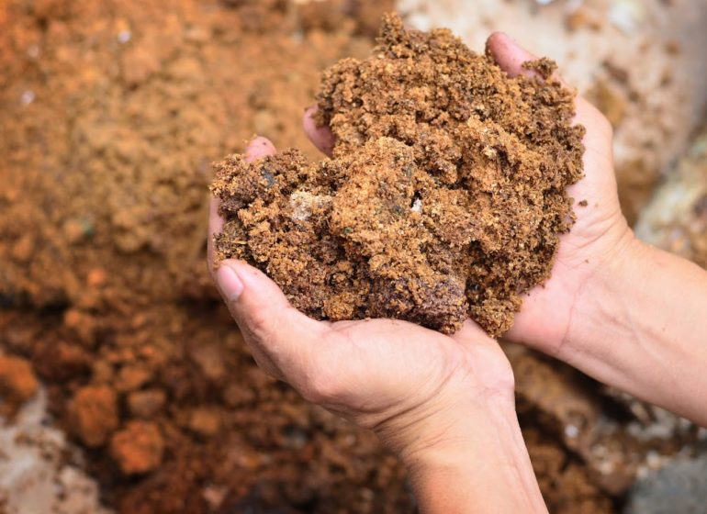
1. Clay: Clay is one of the most versatile earthen materials. It has been used for millennia in the construction of dwellings, pottery, and as a binder in plasters and mortars. Clay is abundant in many regions of the world and can be found in various colours and textures. Its plasticity when wet and strength when fired make it ideal for shaping into bricks, tiles, and vessels.

Using clay to make bricks.

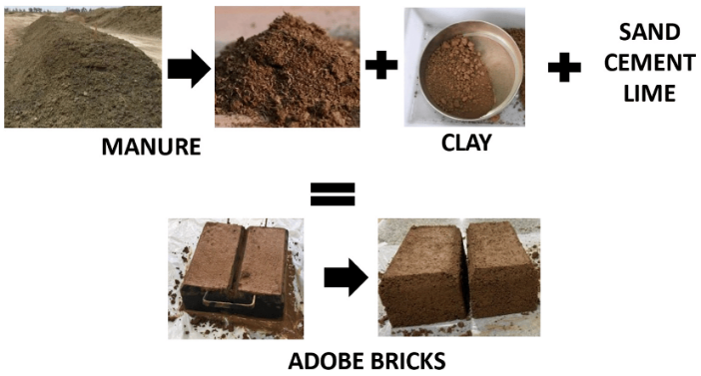
2. Adobe: Adobe is a mixture of clay, sand, straw, and sometimes other organic materials. It is formed into bricks and sun dried. Adobe buildings provide excellent thermal mass, helping to regulate indoor temperature. They provide great flexibility in the design and construction of buildings.

Mixture of clay, manure, sand, cement, and lime.

3. Rammed Earth: Rammed earth construction involves compressing a mixture of earth, gravel, and sometimes stabilizers like lime or cement into sturdy walls. This technique has been used for centuries in regions such as China, Africa, Europe, and the Americas. Rammed earth structures are durable, fire-resistant, and environmentally friendly.
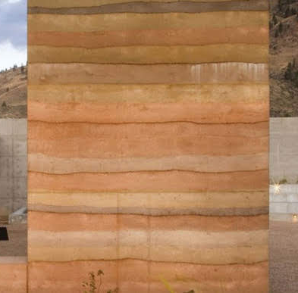

Rammed earth wall

4. Cob: Cob is a mixture of clay soil, sand, and straw that is sculpted by hand into thick walls. It is a traditional building method in England and other parts of Europe. Cob structures often have rounded, organic shapes and provide excellent insulation.
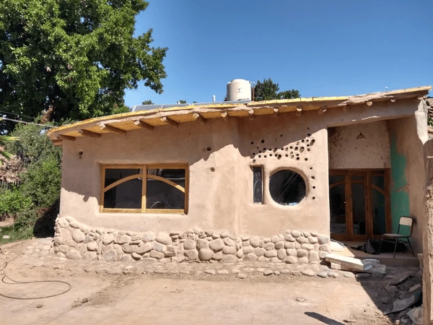

A cob house made up of stone, clay and straw.

5. Plaster: Plaster, made from lime, gypsum, or clay, has been used for centuries to coat interior walls and ceilings. It can be applied in various textures and finishes, providing a smooth or textured surface depending on the application technique. Plaster is durable, breathable, and helps regulate indoor humidity levels.
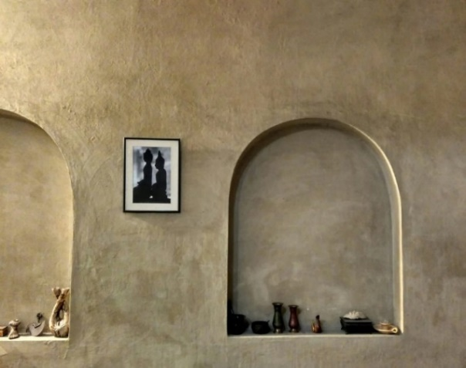

Clay and lime plaster used for interior walls

METHODOLOGY
The dissertation on the use of earthen materials in interior spaces employs a mixed-method research methodology to comprehensively explore the topic. Initially, a systematic literature review is conducted to examine existing scholarly works, research articles, and case studies related to earthen materials, sustainable design, and interior architecture. This review serves as a foundation for understanding the historical context, theoretical frameworks, and practical applications of earthen materials in interior spaces. Following the literature review, qualitative research methods such as interviews, surveys, and site visits are employed to gather primary data from architects, designers, builders, and occupants with experience in working with earthen materials. These qualitative insights provide valuable perspectives on the advantages, challenges, and best practices associated with using earthen materials in interior design. Additionally, quantitative data analysis techniques may be utilized to assess the thermal performance, indoor air quality, and energy efficiency of interior spaces constructed with earthen materials.

LITERATURE STUDY
- Rajkumari Ratnavati Girls School, Jaisalmer, Rajasthan

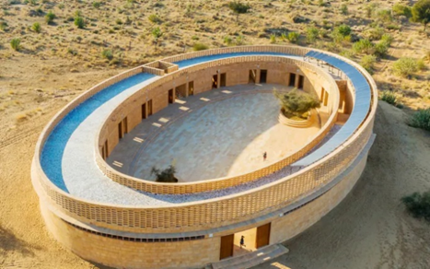
The Ratnavati Girls' School, also known as the "Jaisalmer Golden Fort School," is a notable example of community-driven architecture and sustainable design by using locally available earthen materials, situated in the heart of Thar Desert, approximately 575 kilometres west of the state capital, Jaipur. It exemplifies the thoughtful integration of earthen materials in architectural design. Constructed primarily with locally sourced clay, mud, and sandstone, the school embodies the region's rich cultural heritage while addressing contemporary educational needs. The use of earthen materials not only pays homage to traditional building practices but also ensures sustainability and environmental compatibility within the historic setting of the fort.

Ellipse shaped structure of Rajkumari Ratnavati Girls School.

Awadh Shilpgram, Lucknow, Uttar Pradesh

Awadh Shilpgram in Lucknow, Uttar Pradesh, stands as a testament to the enduring beauty and sustainability of earthen materials in contemporary architectural design. Nestled amidst the bustling city, this cultural village showcases the rich heritage and craftsmanship of the region through its innovative use of locally sourced clay, mud, and other earthen materials. From the intricately designed facades to the traditional courtyard layouts, earthen materials play a pivotal role in shaping the aesthetic and functional aspects of Awadh Shilpgram. The buildings, constructed primarily with adobe bricks and mud plaster and the terracotta Jali work to form the arches, exude a timeless charm while offering natural insulation and thermal comfort, essential for Lucknow's varied climate. Moreover, the use of earthen materials reflects a deep-rooted connection to the land and a commitment to sustainable building practices.

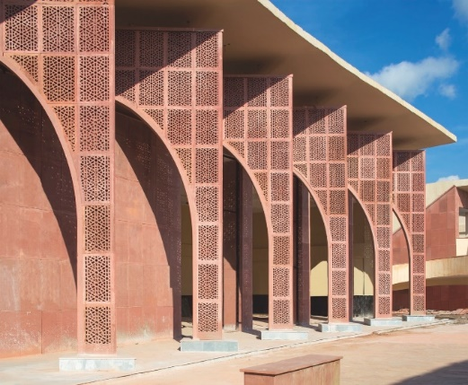
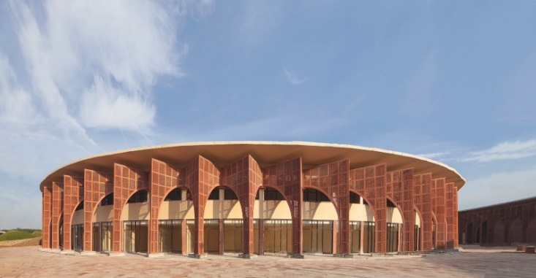
Terracotta Jali work in the arches.

FINDINGS
Pillars of sustainability
The pillars of sustainability serve as guiding principles in promoting the use of earthen materials in interior spaces, aligning environmental consciousness, social equity, and economic viability.
Environmental sustainability lies at the core of utilizing earthen materials, emphasizing their minimal environmental footprint, renewable sourcing, and biodegradability. By harnessing locally available clay, mud, and sand, interior spaces constructed with earthen materials contribute to resource conservation, reduce carbon emissions associated with transportation, and minimize ecological impact.

Zero waste production

Social equity underscores the inclusive nature of employing earthen materials in interior design, fostering community engagement, and empowering local artisans and craftsmen. The use of earthen materials celebrates cultural heritage, traditional building techniques, and indigenous knowledge, promoting a sense of identity and belonging within communities.

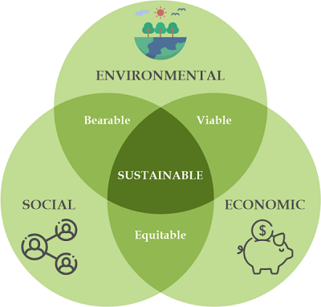

Economic sustainability cab be achieved by using earthen materials

Economic viability underscores the financial sustainability of integrating earthen materials into interior spaces, emphasizing cost-effectiveness, durability, and long-term value. The affordability and availability of earthen materials make them an economically attractive alternative to conventional building materials, reducing construction costs and operational expenses over the building's lifecycle.
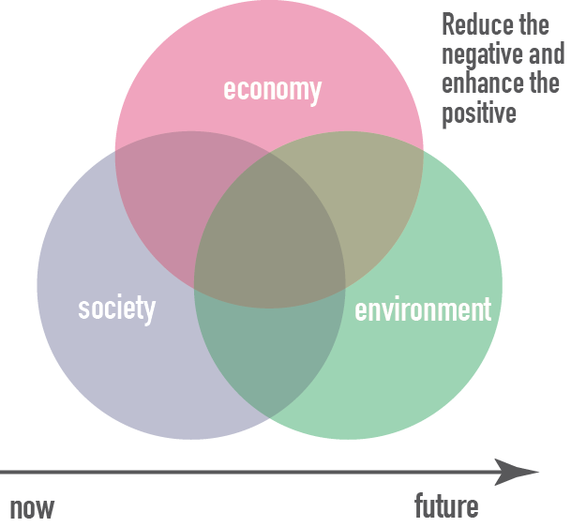

Pillars of sustainability

Cost-reduction
The integration of earthen materials into interior design projects offers significant opportunities for cost reduction without compromising on quality or aesthetics. Earthen materials, such as clay, mud, and adobe, are often locally sourced and abundantly available, resulting in lower procurement and transportation costs compared to imported or specialized materials. The inherent durability and longevity of earthen materials contribute to long-term cost savings. Interior spaces constructed with earthen materials require minimal maintenance and repairs over time, reducing ongoing operational expenses. The natural thermal properties of earthen materials also contribute to energy efficiency, lowering heating and cooling costs throughout the building's lifecycle.

Thermal comfort
Thermal comfort refers to the subjective sensation of being neither too hot nor too cold, but rather feeling just right in an indoor environment. Earthen materials play a crucial role in enhancing thermal comfort due to their natural insulation properties and ability to regulate indoor temperatures effectively. Earthen materials, such as clay, mud, and adobe, have high thermal mass, meaning they can absorb, store, and release heat slowly over time. This property helps to stabilize indoor temperatures by buffering against rapid fluctuations in external conditions, such as temperature variations throughout the day or seasonal changes.
During hot weather, earthen walls and floors absorb excess heat from the surroundings, helping to keep indoor spaces cooler during the day. As temperatures drop in the evening, the stored heat is gradually released back into the interior, maintaining a comfortable environment without the need for mechanical cooling systems. In cold climates, earthen materials act as natural insulators, helping to trap heat indoors and prevent it from escaping to the outside. This insulation effect reduces the need for heating systems and helps to maintain consistent temperatures throughout the living space.
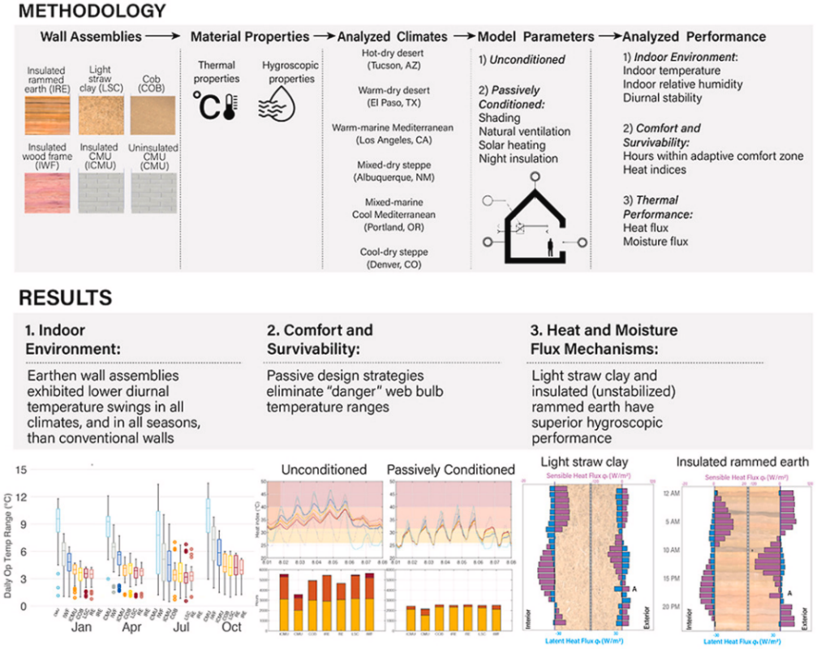

Usage of earthen materials to achieve thermal comfort.

Acoustics
Earthen materials offer unique acoustical benefits that make them valuable in architectural and interior design contexts. One significant advantage is their ability to absorb sound waves, thereby reducing reverberation and improving overall acoustic comfort within a space. Earthen materials such as adobe, rammed earth, and clay plaster have porous and irregular surfaces that effectively scatter and absorb sound energy. When sound waves encounter these surfaces, they penetrate into the material, where they are absorbed and dissipated through frictional losses and internal damping mechanisms. This absorption process helps to mitigate echoes and reduce the overall noise level within a room, creating a more pleasant and conducive acoustic environment for occupants Earthen materials possess inherent thermal mass properties, which contribute to their acoustic performance. The dense and heavy nature of earthen materials allows them to store and release heat slowly over time, helping to stabilize indoor temperatures and regulate humidity levels. This thermal mass effect also extends to sound waves, as the mass of the material absorbs and attenuates sound energy, resulting in improved sound insulation and reduced transmission of noise between adjacent spaces.
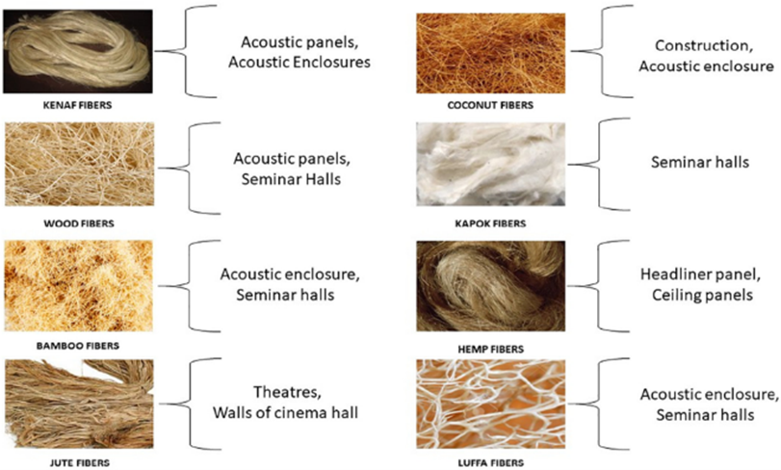

Sound proofing through natural and renewable materials.

HOW CAN EARTHEN MATERIALS BE USED WITH MODERN DESIGN TECHNIQUES

Earthen materials, such as clay, mud, rammed earth, and adobe, can be effectively incorporated into modern design techniques in various ways. Here are several methods:
- Sustainable Construction: Earthen materials are often sourced locally, which reduces transportation costs and environmental impact. By using these materials, modern designs can align with sustainability goals.
- Thermal Mass Properties: Earthen materials have excellent thermal mass properties, meaning they can absorb, store, and release heat over time. Integrating earthen materials into modern designs can help regulate indoor temperatures, reducing the need for mechanical heating and cooling systems.
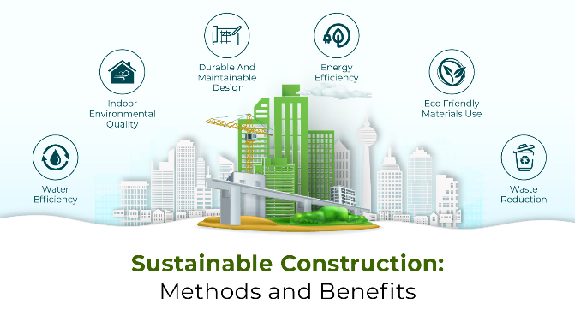

Sustainable construction by using earthen materials that are recyclable.

- Innovative Construction Methods: Modern technologies such as stabilized earth blocks, compressed earth blocks, and rammed earth techniques allow for the efficient and precise construction of earthen structures. These methods enable architects and builders to explore new design possibilities while utilizing traditional materials.
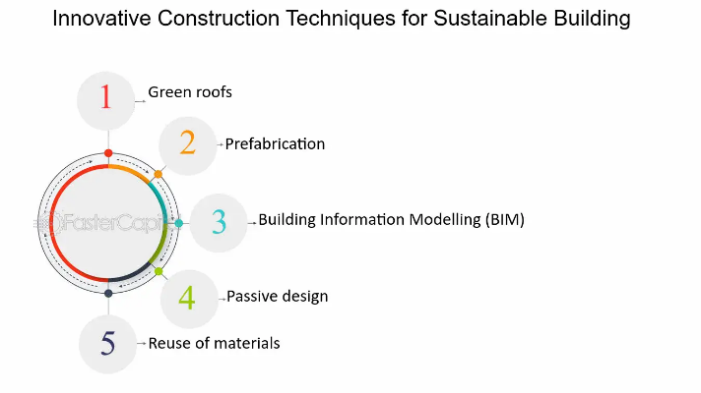

Innovative construction techniques.

- Integration with Other Materials: Earthen materials can be combined with other modern construction materials such as glass, steel, and concrete to create hybrid designs that blend tradition with innovation. This integration allows for creative expressions while maintaining structural integrity and functionality.

- Acoustic Properties: Earthen materials possess good acoustic properties, making them suitable for sound insulation and noise reduction. In modern design, earthen materials can be utilized to create peaceful and acoustically comfortable spaces.

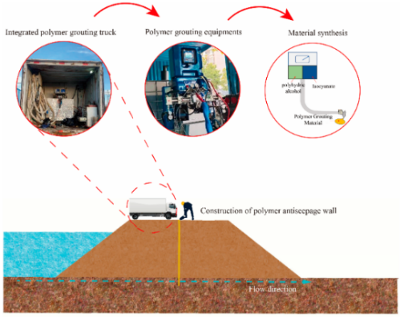

Sustainable use of integrated earthen materials.

CONCLUSION

Based on the comprehensive analysis and insights provided by the dissertation on the use of earthen materials in interior spaces, several recommendations can be made to enhance its impact and relevance in the field of sustainable design. The dissertation aims to inspire further research and experimentation in the application of earthen materials, particularly in addressing specific challenges and opportunities identified in the study.

Through an exploration of historical precedents, contemporary applications, and future possibilities, it underscores the significance of earthen materials in fostering sustainable design practices and creating harmonious living environments. By embracing earthen materials, designers and practitioners can not only mitigate environmental impact but also evoke a sense of connection with nature and cultural heritage. Moving forward, continued research, collaboration, and advocacy are essential for realizing the full potential of earthen materials in shaping the future of interior design towards a more sustainable and inclusive paradigm.

